**MINOR-1 PROJECT**

**SYNOPSIS REPORT**

For

 Electric bus routing and fare optimization system

Submitted By

|  |  |  |
| --- | --- | --- |
| **Specialization** | **SAP ID** | **Name** |
|  |  |  |
|  |  |  |
|  |  |  |



Department of Systemics

School Of Computer Science

UNIVERSITY OF PETROLEUM & ENERGY STUDIES,

DEHRADUN- 248007. Uttarakhand

Dr. Keshav Sinha

**Project Guide Cluster Head**



**School of Computer Science**

University of Petroleum & Energy Studies, Dehradun

**Synopsis Report**

**1. Project Title**

 Eco Trav: Electric bus routing and fare optimization system

**2. Abstract**

The "Eco Trav" project is a novel approach to electric bus routing and fare optimization aimed at providing efficient and eco-friendly urban transportation solutions. The project focuses on utilizing fundamental data algorithms, specifically Dijkstra's algorithm and Ant Colony Optimization, to develop an intuitive and user-friendly system for commuters to navigate electric bus routes while minimizing travel time and cost. By combining graph theory and optimization techniques, the project aims to create a basic yet effective tool for urban commuters seeking the most optimal routes for their journeys.

The heart of the "Eco Trav" system lies in the utilization of Dijkstra's algorithm to calculate the shortest paths between source and destination nodes within an electric bus network graph. This algorithm, well-suited for finding the shortest path in a weighted graph, forms the backbone of the routing component of the system. Additionally, the project employs the Ant Colony Optimization algorithm to introduce a novel element of route optimization, simulating the foraging behaviour of ants to find optimal routes that balance efficiency and exploration.

**3. Introduction**

In the rapidly evolving urban landscape, the need for sustainable and efficient transportation solutions has become more pressing than ever before. As cities grapple with increasing traffic congestion, environmental concerns, and the demand for eco-friendly commuting options, innovative approaches are required to address these challenges. The "Eco Trav" project represents a fundamental yet impactful step toward transforming urban transportation by harnessing the power of data algorithms to optimize electric bus routing and fare calculation.

The essence of the "Eco Trav" project lies in its commitment to simplicity and effectiveness. Rather than relying on complex technologies, the project embraces the principles of data algorithms, utilizing two distinct yet complementary algorithms - Dijkstra's algorithm and Ant Colony Optimization. These algorithms serve as the project's building blocks, paving the way for a refined system that guides commuters toward the shortest and most cost-effective electric bus routes.

Dijkstra's algorithm, a cornerstone of graph theory, is employed to find the optimal path between source and destination nodes in the electric bus network graph. By calculating the shortest route based on graph edge weights, the algorithm lays the foundation for efficient route recommendations. Alongside Dijkstra's algorithm, the project introduces a touch of innovation through Ant Colony Optimization. Inspired by the cooperative foraging behaviour of ants, this algorithm fosters route optimization that strikes a balance between known efficiency and unexplored exploration.

While advanced technologies like cloud computing, AI, and databases are intentionally omitted from the project's scope, this decision accentuates the importance of core concepts. By focusing on data algorithms, the "Eco Trav" project underscores the significance of understanding the foundational principles that drive modern urban transportation systems.

The heart of the "Eco Trav" system lies in its potential to empower commuters with a streamlined interface that encourages eco-friendly choices. By offering commuters the shortest electric bus routes and corresponding fare estimates, the project supports the adoption of sustainable transportation practices. Through this commitment to basic data algorithms and optimization techniques, the "Eco Trav" project contributes to the ongoing discourse on sustainable urban mobility.

As the following sections elaborate on the design, methodology, and implementation of the project, it becomes evident that simplicity need not compromise effectiveness. The "Eco Trav" project exemplifies the fusion of timeless algorithmic principles with contemporary transportation challenges, offering a glimpse into a future where sustainable urban commuting is guided by ingenuity, efficiency, and accessibility.

**4. Literature Review**

Several heap managers have been developed to enhance the performance of allocators in multithreaded settings.

The authors of [1] developed an IoT based heart rate monitoring system using Raspberry Pi not just as a sensor node but also a controller. The heart rate of the patient can be monitored by the doctor or by the guardian without actually visiting the patient.

The authors in [2] describes a technique of measuring the heart rate through a fingertip and show the heart beat on LCD and display the results over the net using local server as well as globally over Thingspeak site.

The authors in [3] implementing heart rate monitoring and heart attack recognition system using IoT. The patient will carry hardware having sensors with android application. The heartbeat sensor will allow checking heart beat readings and transmit them over the internet. The user may set the high and low level of heartbeat limits.

**5. Problem Statement**

Many people have recently become more concerned about abrupt cardiac arrest. With the growing popularity of smart wearable devices, the possibility of providing an Internet of Things (IoT) solution has increased. The Heart Rate Monitoring system using IOT with an objective of detecting the heartbeat of the patient in order to monitor the risk of heart attack and also the regular check-up is developed.

**6. Objectives**

* To monitor the heartbeat of the patient and checks if there is any unusual behaviour or not.
* To trigger a call to the caretaker or the doctor if there is any abnormal behaviour in the heartbeat of the person.
* To store the information in the cloud so that doctors and caretakers can access the data.

**7. Methodology**

* Pulse sensor is interfaced with ESP8266 microcontroller to get the heart rate of the patient.
* The recordings of the heart rate along with patient ID is stored in database so that doctor can check the recordings without vising the patient.
* A sim module is integrated with the system so that an alert call is triggered to the care taker when there is an abormal behaviour seen during the data capture.
* A front end website will be developed to extract the data from the database for particular patient.

**8. PERT Chart**

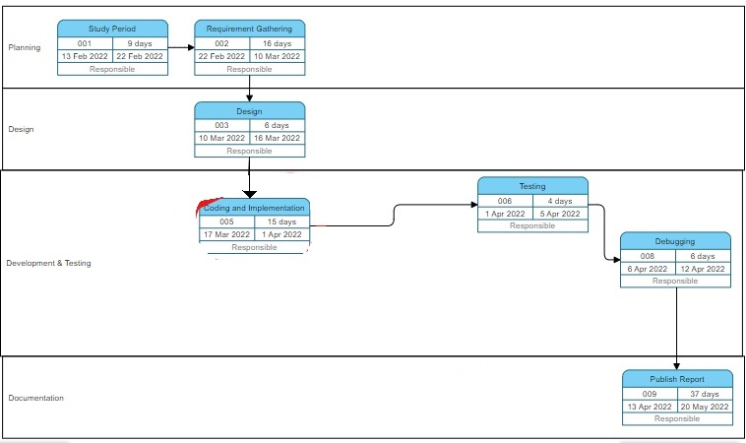

**9. Results**

Two web applications are built using Java Swing that is one for patient admin and other doctor to monitor the heart beat of the patient. In patient web application the dial button is integrated for calling in case of abnormal behaviour shown by BPM. The figures below shows the BPM of the patient in doctor panel and in patient panel.

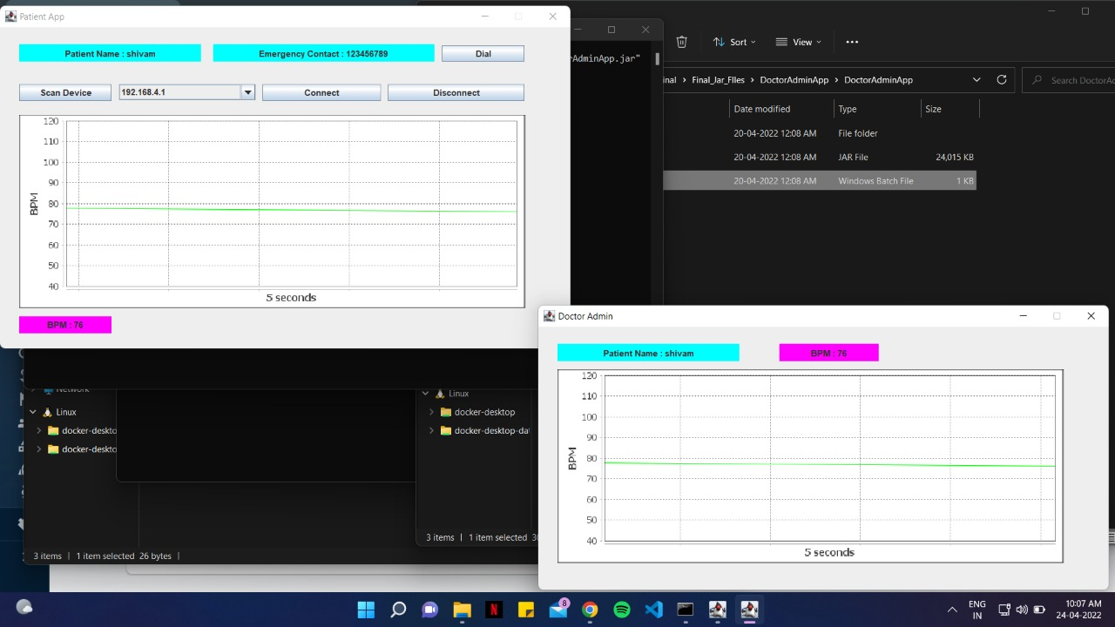

Patient web application Doctor web application

An android application is also developed for doctor. Doctor should register before checking the heart beat of the patient. Once he is registered, he can login with his details and check the BPM of the patient. Figure below shows the interface of the android application.

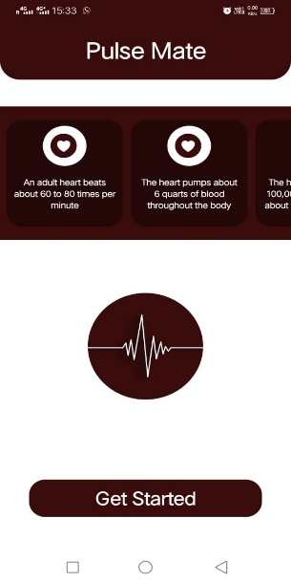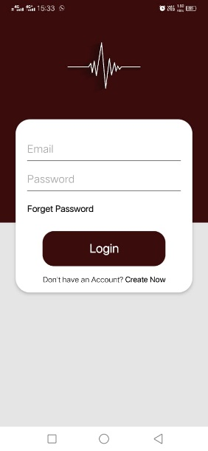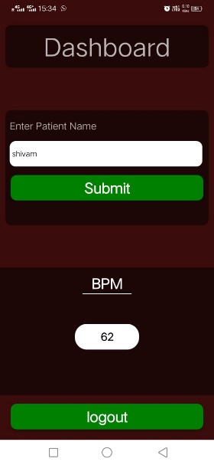

Doctor Android Application

**10. References**

[1] I. Journal, S. S. Kazi, G. Bajantri, and T. Thite, “Remote Heart Rate Monitoring System Using IoT,” International Research Journal of Engineering and Technology, 2018, Accessed: Mar. 14, 2022. [Online]. Available: www.irjet.net

[2] V. Goel, S. Srivastava, D. Pandit, D. Tripathi, and P. Goell, “Heart Rate Monitoring System Using Finger Tip through IOT,” International Research Journal of Engineering and Technology, Accessed: Mar. 14, 2022. [Online]. Available: www.irjet.net

[3] N. Patel and P. Patel, “Heart Attack Detection and Heart Rate Monitoring Using IoT,” Nehal Patel International Journal of Innovations & Advancement in Computer Science, 2018, Accessed: Mar. 14, 2022. [Online]. Available: https://www.researchgate.net/publication/329268152

**11. GitHub Link**

[https://github.com/viteshseth](https://github.com/viteshsethi18/Heart-Rate-Minor-2)

[i18/Heart-Rate-Minor-2](https://github.com/viteshsethi18/Heart-Rate-Minor-2)